Fill in the student details in the box.
Student Name | Bahashta Nooristani
Student ID | 23517363

Notes on the exercises
- This lab contains 2 parts. Fill your answer in the required place.
- Do not change the font size.
- Plagiarism and copying are serious offences in the university (https://www.dcu.ie/policies/academic-integrity-plagiarism-policy).
- Submit this report on Loop after you finished.
- The deadline is 6th March 2026.
- Late submission penalty: 10% decrease per day.

VirtualBox Setup
If you have successfully completed the DNS Lab. You are good to go, skip this step.

Otherwise, to set this up we need to import the below server and client into your VirtualBox

Client: https://drive.google.com/file/d/1M5zLZXz86sNaQSVSQkjrHX2fMVXbBIaY/view?usp=sharing

Server: https://drive.google.com/file/d/19JzrmlAL7u0fHxsGjktwaqdKqgh4NvVx/view?usp=sharing

Open VirtualBox and select “Import”, on the settings screen change the name of the server form VM to “Server”. Choose Generate new MAC address for all next work adapter for MAC Address Policy, then click Finish to start importing.

Repeat the import process again and this time change the name to “Client”.

The username for both machines is “student” and the password is “computing” (without quotes).

Part 1: Test the TCP/IP Protocol Configuration
Use ifconfig to find out the IP address and Ethernet adapter’s hardware address (physical address with 6 bytes expressed in hexadecimal) of your Client virtual machine.
Answer:
IP address | 192.168.10.2
MAC address | 08:00:27:38:08:07

Display the output for ping –c 1 ubuntusever.computing.org in the Client machine. Provide a screenshot here:
Answer:
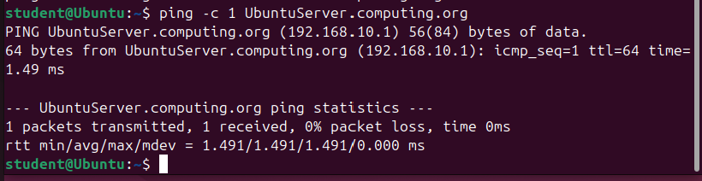

Explain the output for ping –c 1 ubuntusever.computing.org in detail, item by item.
Answer:

PING UbuntuServer.computing.org (192.168.10.1): This shows that the domain name UbuntuServer.computing.org was translated by DNS into the IP address 192.168.10.1.

56(84) bytes of data: This shows the size of the packet being sent to the server.
64 bytes from UbuntuServer.computing.org (192.168.10.1): This means the server successfully responded to the ping request.

icmp_seq=1: This shows the sequence number of the packet. Since we used -c 1, only one packet was sent.

ttl=64: TTL stands for Time To Live. It shows how many network hops the packet can make before it is dropped.

time=1.49 ms: This is the time it took for the packet to travel from the client to the server and back.

1 packets transmitted, 1 received, 0% packet loss: This shows that one packet was sent and one packet was received.
There was no packet loss, which means the connection is working properly.

Part2: Demonstration

Specify a fixed IP address for a host.

You have to finish the DNS lab before you start this part.

Power on your Server.

Modify the configuration file dhcpd.conf in the Server.
Make the Client machine as a host. Specify the IP address 192.168.10.11 to the host.

After modifying the DHCP configuration file, restart your DHCP service to update your configurations.

Reissue the IP address for the Client by killing the old process and then requesting a new process using the below commands:
Sudo dhclient –r
Sudo dhclient

Now, you will see the new IP address on your Client machine when you place ifconfig in the terminal.

Demonstrate the result for the following commands to the lecturer or the TA to get 2 marks:
Ping –c 1 fixed.computing.org
Ping –c 1 192.168.10.11

Place a screenshot below if you HAVEN’T succeed demonstrated it to them.

